Lab6 Introduction to JUnit

Find the code for this lab on BB under Lab 6.

Using JUnit in Netbeans, create and run a set of simple test on the class SodaMachine in the fifty cent state. This code is the "State" design pattern implemented in a "Soda Machine" that vends "Mountain Dew". It has a GUI.

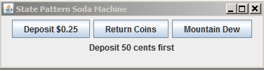

The "states" are 0, 25, and 50 cents. Run the application to get the hang of it. Then, create a set of test for the SodaMachine class. Test each method until all assert true.

The expected output for each method is (excluding quotes):

- testCoinReturn = "$0.50 returned"
- testCoinSlotDeposit = "Coin returned - $0.50 already deposited"
- testSodaButton = "Your soda has been vended"

You should also test SetCurrent(SodaState s) and assert that current is an instanceof FiftyState.

First run after creating the test might result in this:
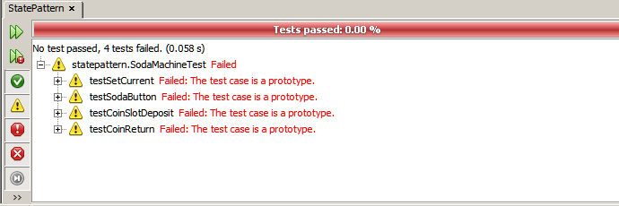

After successfully setting up the test the result should be:
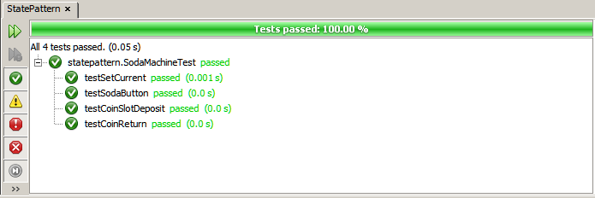

Submit the test class only to the Dropbox for this lab.

